*Lab 1: Resistance*

Physics 411

John Waczak

10/8/2016

Lab Partner: Kyle Tafoya

Introduction/Background

The goal of the series of experiments encapsulated in this lab was to study the electrical property of resistance. Resistance is defined as the opposition to the flow of charge. This property depends both on the dimensions of the object upon which a current is applied and upon an innate physical attribute called its resistivity which reflects the atomic composition of the particular object.1

Various electrical components make use of the property of resistance. Some are simply used to control the way current flows or how voltage is divided throughout a circuit, others like diodes may be employed to ensure current is flowing in a desired direction. An object’s resistance may also be used to dissipate power in a desired way. For example, Light Emitting diodes make use of their electrical resistance to dissipate power as light. Other items such as passive resistors convert the translational energy of electron motion into thermal.

There are two distinct classes of resistors: Ohmic and Non-Ohmic. The current through an ohmic resistor is directly proportional to the voltage drop across its leads with a slope of 1 over the resistance.2 Non ohmic resistors may exhibit little to zero current in a particular direction and proceed to grow exponentially in the positive direction among other trends. This lab examined the relationship between current and voltage drop for various electrical components including resistors, diodes, and thermistors. The temperature dependence of both resistors (copper clad) and thermistors was also examined. Next, the simple potential divider circuit was analyzed to determine which values of resistors would produce a near constant load voltage, afterwards the circuit was analyzed using the concept of Thevenin equivalence. Finally, the source input voltages were measured for both the 10 volt power supply and the digital multi-meter (DMM).

The report that follows will discuss the circuit design and experimental procedure. Data will be presented in graphs with raw data included in appendices at the end of the report. Data will be examined in reference to theoretical models and pre-lab predictions.

Theory/Circuit Diagrams/Experimental Procedure

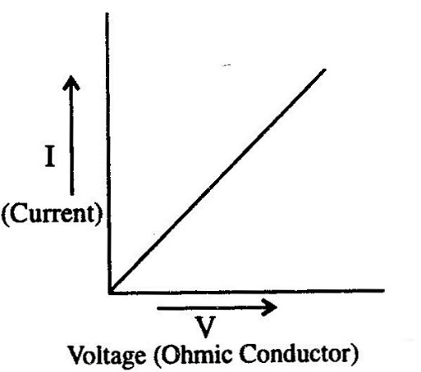

1. **Ohmic Behavior of resistors**

Resistors are generally considered to display Ohmic behavior within a particular current range and under standard conditions for temperature and pressure. The first experiment in this lab analyzed the behavior of resistors in order to determine how Ohmic they are. Resistors were then compared to thermistors in order to analyze the temperature dependence of resistance for these two components.

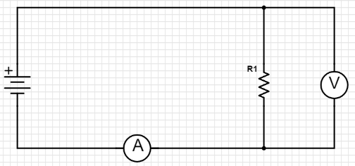Simply measuring the resistance of a component does not provide enough information to decisively determine over what range of currents the component displays Ohmic behavior. Instead, a wide range of current should be tested in order to create what is called an I-V curve. This is a graph of the dependence of current on the voltage drop across a component and any Ohmic behavior would persist as a linear relationship where the slope is one over the resistance of that component. Figure one shows an example I(V) curve for an Ohmic component.

Figure 1: An Ohmic component3

Figure 2 shows the circuit construction for part one of this lab. A resistor was connected to the tabletop power supply. Both a voltmeter and ammeter were used (DMM) to measure the voltage and current of the system.

Figure 2: The circuit diagram for experiment 1

In order to measure the temperature dependence of the resistance for both a copper clad resistor and a thermistor, a thermocouple was used in conjunction with the DMM to measure the resistance of the two components as we changed their temperature using a heat gun and a bucket of ice.

1. 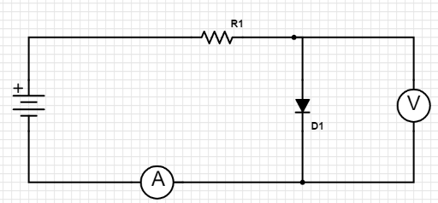**I(V) dependence for other materials and objects**

For the second experiment in this lab, the I(V) relationships were measured for components other than simple resistors including a length of graphite, a simple diode, and a light emitting diode. For all three components, a current limiting resistor was used in series with the diode to prevent any rapid heating of the components. The resistor used for the graphite rod was a 1 watt 100 ohm resistor. A 100k resistor was used for both diodes in order to limit the current to less than 100 mA. Figure 3 shows the circuit diagram for the second experiment. In the diagram, R1 represents the current limiting resistor and D1 is where the graphite/diodes was placed. (*note by using the diode symbol I am not trying to imply that the graphite acts like a diode)

Figure 3: The circuit diagram for experiment 2

After measuring the I(V) dependence of the graphite rod, the resistivity ($ρ$) was determined using the equation:

$ρ=R \frac{A}{L}$ $[5]$

Where R is the resistance, A is the cross-sectional area, and L is the length of the object.

1. **Potential or Voltage Divider**

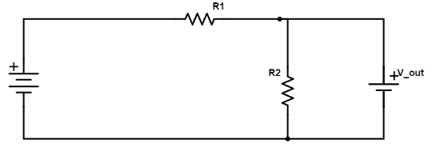The third experiment in this lab examined the capabilities of the circuit dubbed the “Voltage divider”. Figure 4 shows the circuit diagram for the potential divider. From Kirchoff’s loop laws one can deduce that the equation for the output voltage, V_out, is given by the equation:

Figure 4: Potential Divider circuit for experiment 3

$V_{out }=V_{in}∙\frac{R1}{R1+R2}$ [6]

However, this equation is only true for the open circuit voltage across the resistor R2. Once a load is attached, the output voltage may change depending on the resistance of the load. To examine this as well as the effects of change the values of R1 and R2, the current through and voltage across a load resistor was measured for various resistances. In the first run, R1 = R2 = 200 ohms. In the second run, R1 = R2 = 16k. The values for resistance and voltage were measured using 2 digital multi-meters.

1. 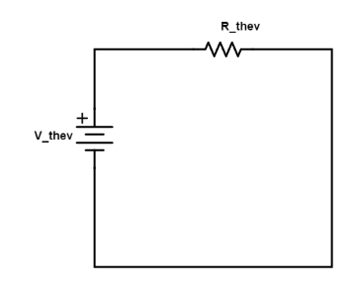**Thevenin equivalent potential and resistance**

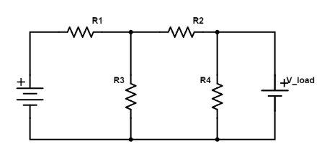

Figure 5: Complicated circuit for experiment 4

Figure 6: The Thevenin equivalent circuit

The fourth experiment in this lab examined the validity of the concept of Thevenin Equivalence. Thevinin Equivalence states that any circuit composed of voltage sources and resistors can be represented by a “black box” containing a single V_thev and R_thev representing the equivalent voltage and resistance for a point on a complicated circuit as shown in figure 6 above. Figure 5 shows the complicated circuit used for experiment 4. Resistors R1, R2, R3 and R4 all had a resistance of 139k Ohms.

First, the equivalent source potential was measured by shorting the connection (denoted V_load in figure 5) with the DMM and measuring the potential. Next, the equivalent resistance was measured over the same connection by measuring the current through the short circuit. Finally, a series of load resistors were used to further measure the output potential of the circuit in order to create an I(V) curve and examine the behavior of the Thevenin “Black box”.

1. **Source and input resistances**

The final experiment in this lab examined the source and input resistances of two of the primary pieces of equipment used in the electronics lab: the tabletop power supply and the digital multi-meter. In order to measure the source resistance of each item the concept of Thevenin equivalence used in experiment 4 was employed with the “black box” in this case being the unknown circuitry of the power supply and digital multi-meter.

Prior to conducting the experiment, the hypothesized value for the power supply was on the order of 10 ohms as any significant resistance would mean that the displayed voltage would be greater what was actually supplied between the device’s leads. On a similar note, the value for the DMM was hypothesized to be on the order of a mega-ohm as an ideal voltmeter should have nearly infinite resistance in order to prevent any current from being sampled (this would inevitably impact the voltage measured).

For each device, the open circuit voltage across the leads was measured as well as the current produced by shorting the leads with the DMM set to current. Finally, as in experiment 4, various resistors were employed in order to measure the I(V) and V(R) dependencies. Figures 7 and 8 below show the circuit’s employed for each test. 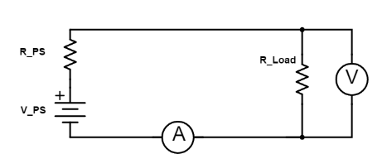

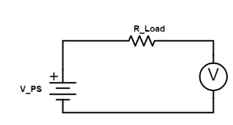

Figure7: Power Supply test circuit

Figure 8: DMM test circuit

Results/Data/Graphs

1. **Ohmic Behavior of resistors**

(a) The value of the resistor provided by the instructor was measured to be 98.6 kΩ with an uncertainty of +/- 0.05 kΩ. The class average for the resistor was 98.6 kΩ +/- 0.5 kΩ.

(b) The value of the measured resistor was 220kΩ. This however is not enough information to decide whether the resistor is Ohmic or non-Ohmic as that quality depends on how the resistor works under various currents.

(c) Graph 1 shows the I(V) curve for the 220kΩ resistor. As the graph shows, the data is very linear suggesting the simple resistor is Ohmic. In fact, the trendline excel fitted to the data has an R2 value of 0.9999 with a slope that is exactly 1 divided by the resistance.

Graph 1: 220 k-Ohm resistor I-V dependence

$$Slope=\frac{1}{R}=\frac{1}{220000}≈5.0*{10}^{-6}$$

In this case the results agree with the theoretical expectation. The best fit trend line matches the theoretical description of an Ohmic resistor. Raw data from parts (a)-(c) can be found in appendix 1.

(d) Graph 2 shows the dependence of the resistance of a copper clad resistor on temperature.

Graph 2: Temperature dependence of copper clad resistor

As the data clearly shows, the resistance of the 75 ohm copper clad resistor remains nearly constant. This data suggest that resistors are very versatile, varying only slightly over a 50 degree temperature range.

(e) This constant nature is not the case for the thermistor as its name would suggest. Data for the thermistor’s resistance as a function of temperature is shown in Graph 3 below:

Graph 3: Thermistor temperature dependence

An exponential trend was fitted to the data as it had the highest R2 value of all of the trend types. One data point in particular, the value for 58 degrees, could be erroneous as there was some trouble in getting a good reading using the thermocouple at some temperatures. It is particularly interesting that the data shows a decrease in resistance as temperature increases because in general this disagrees with theory. As the temperature of an object increases, the random motion of the electrons therein also increases making it more difficult for electrons to translate through an object in one net direction.6 It would appear that as opposed to the copper clad resistor, the resistance of the thermistor is a “dramatic” function of temperature in that the resistance sharply increases as the temperature decreases. The raw data for the temperature dependencies of resistance can be found in appendix 2.

1. **I(V) dependence for other materials and objects**

(a) The I(V) curve for a graphite rod of diameter 2mm and length 6.3 cm was obtained. The data is illustrated in graph 4 below:

Graph 4: I(V) dependence for graphite rod

The linearity of this data, as evidenced by the R^2 value, suggests that the rod of graphite acts as an Ohmic resistor of a very low resistance. In fact, even with the 1 watt 100 ohm resistor in series, the graphite began to heat excessively as the current approached 200 mA.

From the I(V) dependence, the resistance of the graphite may be deduced (one over the slope) to be: $R=\frac{1}{slope}= \frac{1}{2.99}=0.33 Ω$. Using this value, the resistivity of graphite is calculated to be:

$ρ=R∙\frac{A}{L}=0.33∙\frac{2π∙{\left(1∙{10}^{-3}\right)}^{2}}{6.3{∙10}^{-2}}=3.29{∙10}^{-5}$ Ωm

This result is on the same order of magnitude for the literature value of the resistivity for graphite suggesting the method of analysis is reliable.7

(b/c) The I(V) dependence for both the simple diode and light emitting diode is much different from that of the graphite and other Ohmic resistors. This is illustrated in graphs 5 and 6 below:

Graph 6: LED I(V) dependence

Graph 5: Diode I(V) dependence

Clearly in both cases, the diodes prevent current (values were in the micro-amp scale) from flowing in the negative direction. When a positive voltage was applied, the current appeared to increase exponentially. These facts together indicate that diodes do not behave as Ohmic resistors.

1. **Potential or voltage divider**

Two sets of potential dividers were created (see figures 5 and 6 in previous section) with resistance values of R1=R2=200Ω and R1=R2=16kΩ. A series of load resistors were tested on the circuit in order to determine which would provide a more constant voltage. As mentioned previously, the general voltage divider equation is $V_{out }=V_{in}∙\frac{R1}{R1+R2}$. However, in this case, as we add R_Load in parallel to R2, the Equation changes so that $V_{out }=V_{in}∙\frac{R1}{R1+R_eq}$. Where R_eq is equal to the reciprocal of one divided by R2 plus one divided by R_Load giving:

$V_{out }=V_{in}∙\frac{R1}{R1+\frac{R2+R_laod}{R2*R_load}}$. Clearly, when R_Load << R2, the ratio becomes large, reducing the voltage V_out. Alternatively, when R_Load >> R2, the ratio’s contribution becomes smaller and smaller resulting in V_out achieving a voltage level close to 1/2 V_in. Based upon these equations one would expect that in the first potential divider where R1=R2=200 Ω to provide a much more constant value of V_out as R_load will be much bigger in most cases. Graphs 7 and 8 below show the data collected for the two voltage dividers.

Graph 7: Voltage Divider R = 200 Ohms

Graph 8: Voltage Divider with R= 16k-ohms

Graph 7 shows that for resistance values at or above roughly 8 kilo-ohms, the voltage divider provides 5.1 volts across the load (the V_in value in both cases was 10.3 volts). Graph 8 Shows a wide variation in voltage with only values above the 200kilo-ohm, two orders of magnitude larger, nearing the value of 0.5 V_in.

The raw data for experiment 3 can be found in appendix 3.

1. **Thevinin equivalent potential and resistance**

Experiment number 4 examined the applications of the concept of Thevenin equivalence (detailed in the preceding section). The complicated circuit detailed above in Figure 5 was created with R1=R2=R3=R4= 139 Ohms. The Thevenin equivalent Voltage V_Thev and resistance R_thev were calculated first using Kirchoff’s loop laws, and then measured by analyzing the open circuit voltage, short circuit current, and the voltage dependence on the load resistance.

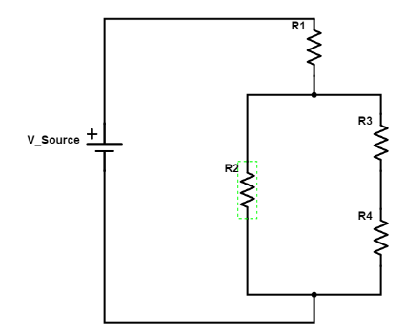

Simplifying the circuit diagram, we get the equivalent circuit shown in figure 9 to the right. For this experiment R1=R2=R3=R4=R=139 Ohms

Kirchoff’s loop law simplifies down to two equations that can be used to calculate V_thev:

Figure 9: Simplified Circuit Diagram

$$I_{1}=\frac{V_{source}}{R_{eq}}=\frac{V_{source}}{R+{\left(\frac{1}{R}+\frac{1}{2R}\right)}^{-1}}=\frac{{3V}_{source}}{5R}=0.0445 am$$

$$I_{3}=\frac{V_{Source}\left(1-\frac{3}{5}\right)}{2R}=\frac{V_{Source}}{5R}=0.0148 amps$$

Using these two equations we conclude that:

$$V_{thev}=V_{source}-I_{1}R-I_{2}R=10.3-\left(0.0445*139\right)-\left(0.0148*139\right)=2.06 Volts$$

In order to determine the R_thev resistance, the voltage sources are replaced by bare wire and the equivalent resistance to the desired point is calculated. The simplified circuit diagram is shown in figure 10 to below:

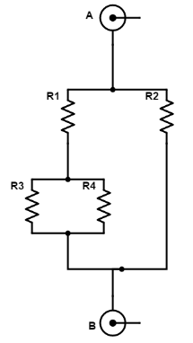

Figure 10: Simplified circuit for calculating R_Thev

In figure 9, the points circled A and B are where we are determining R_thev. By using the rules for series and parallel resistors we find that:

$$R_{thev}={\left(\frac{1}{R}+\frac{1}{R+{\left(\frac{1}{R}+\frac{1}{R}\right)}^{-1}}\right)}^{-1}=\frac{3R}{5}=83.4 Ohms$$

In summary, the circuit analysis using Thevenin Equivalence gives values V_Thev = 2.06 volts and R_Thev = 83.4 Ohms. These results were verified by placing different load resistors and measuring the I(V) dependence of the system. The following graph illustrates the observed relationship.

Graph 9: The Thevenin equivalent I(V) dependence

The measured open circuit voltage = V_thev was 1.9 volts. Similarly, the short circuit current was 26.7 mA giving a R_thev value of 71.2 ohms. From graph 7, the R_thev value is equivalent to – 1 divided by the slope giving another measurement for R_thev to be 72.5 ohms.

The data for experiment 4 can be found in appendix 4.

1. **Source and input resistances**

The method of Thevenin equivalence from experiment 4 was applied again in order to evaluate the source resistance of the tabletop power supply as well as the input resistance of the digital multi-meter in voltage mode. Ideally, a power supply should have zero source resistance so that the entire voltage can be applied to the load. Similarly, an ideal voltmeter would have infinite resistance so that no current passes through the meter. Graphs 10 and 11 show the data obtained for the Power supply and DMM.

Graph 10: I(V) dependence of power supply

Graph 11: V(R) dependence for the DMM

As in experiment 4, the Source Resistance for the power supply is simply -1 divided by the slope of the I(V) graph. It is worth mentioning that for this plot, the R squared value was slightly less at 0.8162. This is likely due to the fact that for a couple of data points, the current limit was reached for the power supply resulting in a drop in V_source from the set point value. Regardless, the value of R_source = 1.189 ohms which is on the order of magnitude expected for a power supply.

Due to the fact that the DMM has such a high resistance, the standard I(V) plot could not be obtained as the currents were so low, they could be measured precisely. However, as the load resistor changed (and approached large values), the value of the voltage drop across the meter was measurable resulting in the above data in graph 11. By utilizing the trendline fitted to the data, the value of R_input can be obtained by interpolating to the corresponding value for ½ the V_source, since the Thevinin “black box” combined with the load resistor result in the standard voltage divider circuit described previously. Using the trendline equation R_input = 9.91 mega Ohms. This value is also in agreement with the theoretical model for an ideal voltmeter as 9.91 mega ohms is an extremely high resistance.

The raw data for experiment 5 can be found in appendix 5.

Conclusions

The various experiments in lab one helped to create a complete picture for the electrical property of resistance. Experiment one illustrates that simple resistors display Ohmic behavior (as opposed to other components) with an I(V) dependence proportional to one divided by the resistance. Furthermore, the experiment demonstrated the relative consistence of the value of a resistor’s resistance over a wide range of temperatures. This was clearly not the case for the thermistor which displayed an almost exponential relationship between temperature and resistance.

Experiment two explored components other than simple resistors in order to examine their Ohmicity (whether or not they were Ohmic). The graphite rod was shown to act very Ohmic but with an extremely low resistance on the order of 0.33 Ω. Due to this low resistance, Ohmic heating was a significant problem as the current drawn through the graphite began to dramatically increase. Using the dimensions of the graphite rod and the determined resistance, the characteristic resistivity of graphite was determined to be: $3.29{∙10}^{-5}$ Ωm.

The simple diode and light emitting diode were both shown to display non-ohmic characteristics. For negative voltages, nearly no current passed through the resistor. In the other hand, positive voltages produced an exponential I(V) dependence reflecting the fact that diodes are typically used to prevent current from travelling backwards, rather than acting as resistors.

Experiment three analyzed the output voltage of the voltage (potential) divider circuit. In accordance with theory, the data illustrated that small values of R1 and R2 produce a more constant voltage as the divider equation for V_out becomes dominated by the R_load value rather than R1 and R2.

Next, experiment 4 illustrated the concept of Thevenin Equivalence. The complicated circuit given by the instructor could be modeled by a “black box” with V_thev and R_thev. This theory was tested by measuring the short circuit current, open circuit voltage, and the I(V) dependence for various values of load resistance. The calculated R_thev value was 83.4Ω while the measured value was in the low 70Ω’s. Similarly, the calculated value for V_thev was 2.06 volts while the measured value was 1.9. These slight differences could be due in part to the input resistances introduced by the meters used to measure the current and voltage.

Finally, experiment 5 demonstrated the use of Thevenin equivalence to evaluate the source resistance of the power supply and the input resistance of the digital multi-meter on the voltage setting. The values for R_source and R_input were 1.189Ω and 9.91MΩ. These values are in accordance with the theoretical values for both an Ideal power supply (extremely low resistance) and an ideal voltmeter (an almost infinitely high resistance).

The practical knowledge gained from these experiments extends from circuit design, to circuit analysis. The methods used will be vital for further experimentation of more complicated circuits.

Appendices

Appendix 1:

*I(V) dependence for a simple resistor*

|  |  |  |
| --- | --- | --- |
| R(kO) | V (volts) | I (A) |
| 220 | 1.021 | 0.0000047 |
| 220 | 1.329 | 0.0000061 |
| 220 | 1.82 | 0.0000084 |
| 220 | 2 | 0.0000094 |
| 220 | 2.2 | 0.0000103 |
| 220 | 2.4 | 0.0000117 |
| 220 | 3 | 0.0000142 |
| 220 | 3.3 | 0.0000155 |
| 220 | 3.6 | 0.0000168 |
| 220 | 3.8 | 0.0000182 |
| 220 | 5.9 | 0.000028 |
| 220 | 13.8 | 0.0000647 |
| 220 | 17.8 | 0.0000833 |
| 220 | 20 | 0.0000935 |

*Temperature Dependence of copper clad resistor*

|  |  |
| --- | --- |
| Temp(celsius) | Resistance (ohms) |
| 21.4 | 71.8 |
| 24.6 | 72.2 |
| 29.2 | 72.5 |
| 50 | 73.6 |
| -4 | 73.1 |
| -1.7 | 72.8 |
| 20.6 | 72.9 |
| 21.1 | 73 |
| 22.3 | 73 |

*Temperature dependence of Thermistor*

|  |  |
| --- | --- |
| Temp (F) | Resistance (kO) |
| 76 | 10.3 |
| 90 | 5 |
| 92 | 4.5 |
| 82 | 6.38 |
| 78 | 7.2 |
| 73 | 13.2 |
| 58 | 23.8 |
| 70 | 20 |
|  |  |

Appendix 2:

*The I(V) dependence of graphite rod*

|  |  |
| --- | --- |
| V (volts) | I (A) |
| 0.014 | 0.0406 |
| 0.017 | 0.0511 |
| 0.02 | 0.0591 |
| 0.025 | 0.0751 |
| 0.029 | 0.0855 |
| 0.033 | 0.0975 |
| 0.012 | 0.0359 |
| 0.007 | 0.0207 |
| 0.003 | 0.0107 |
| 0.002 | 0.00683 |

*The I(V) dependence of the simple diode*

|  |  |
| --- | --- |
| Voltage (volts) | Current (amps) |
| 0.199 | 0.0000002 |
| 0.343 | 0.0000057 |
| 0.369 | 0.0000103 |
| 0.383 | 0.0000139 |
| 0.396 | 0.0000189 |
| -0.455 | 0 |
| -0.818 | 0 |
| -1.45 | -0.0000001 |
| -1.779 | -0.0000001 |
| -2.5 | -0.0000002 |

*The I(V) dependence of a LED*

|  |  |
| --- | --- |
| Voltage (V) | Current (A) |
| 2.2 | 0.0000249 |
| 2.5 | 0.0007 |
| 2.9 | 0.0084 |
| 3.1 | 0.0201 |
| 1.7 | 0 |
| -1.7 | 0 |
| -2.2 | 0 |
| -2.6 | -0.0000002 |
| -3.1 | -0.0000002 |
| -3.6 | -0.0000003 |

Appendix 3:

*Potential Divider with R1=R2=200 ohms*

|  |  |  |
| --- | --- | --- |
| R(load) (Ohms) | V(load) (Volts) | I(load) (Amps) |
| 199.1 | 3.3 | 0.0169 |
| 670000 | 5.1 | 0.000008 |
| 1010000 | 5.1 | 0.0000055 |
| 19700 | 5.1 | 0.0002 |
| 210000 | 5.1 | 0.0000239 |
| 464 | 4.1 | 0.009 |
| 610 | 4.3 | 0.0072 |
| 980 | 4.5 | 0.0046 |
| 8070 | 5 | 0.0006 |
| 1980 | 4.8 | 0.0024 |
|  |  |  |

*Potential Divider with R1=R2= 16k Ohms*

|  |  |  |
| --- | --- | --- |
| R(ohms) | Voltage (volts) | Current (Amps) |
| 19800 | 1 | 0.0004 |
| 206 | 0.127 | 0.0006 |
| 8090 | 2.6 | 0.0003 |
| 614 | 0.3 | 0.0005 |
| 677000 | 5.1 | 0.0000079 |
| 985000 | 0.573 | 0.0005 |
| 19900 | 3.7 | 0.0001793 |
| 470 | 0.288 | 0.0006 |
| 217000 | 5 | 0.0000232 |
| 1980 | 1.041 | 0.0005 |

Appendix 4:

*Thevenin Equivalent for complicated circuit*

|  |  |  |
| --- | --- | --- |
| V(ab) = | V(open) | 1.9 volts |
| Resistance (ab) | Voltage (ab) | Curent (ab) |
| 989000 | 1.89 | 0.0018 |
| 677000 | 2 | 0.0000031 |
| 622000 | 1.81 | 0.0029 |
| 217000 | 1.9 | 0.0000094 |
| 19900 | 1.8 | 0.0000965 |
| 1980 | 1.9 | 0.0009 |
| 8090 | 1.9 | 0.0002 |
| 211 | 1.472 | 0.0073 |
| 475 | 1.745 | 0.0037 |
| 520 | 1.765 | 0.0034 |
| 33.3 | 0.422 | 0.0212 |
| 820 | 1.856 | 0.0022 |
| 103.7 | 1.109 | 0.0121 |

Appendix 5:

*Source Resistance*

|  |  |  |
| --- | --- | --- |
| R(ohms) | V (Volts) | I (amps) |
| 106.3 | 4.7 | 0.053 |
| 217000 | 5.1 | 0.0000238 |
| 19950 | 5.1 | 0.0002 |
| 2000 | 5.1 | 0.0025 |
| 1010 | 5 | 0.0051 |
| 8110 | 5.1 | 0.0006 |
| 500 | 5 | 0.0108 |
| 680000 | 5.1 | 0.0000079 |
| 226.8 | 4.9 | 0.0251 |
| 630 | 5 | 0.0082 |
| 8 | 5 | 0.0062 |
| 5300 | 5 | 0.0098 |
| 50 | 4.9 | 0.21 |
| 35 | 4.8 | 0.5 |
| 57 | 4.9 | 0.15 |
| 4.3 | 4 | 0.93 |

*Input Resistance*

|  |  |
| --- | --- |
| R(ohms) | V(volts) |
| 19.5 | 1.526 |
| 300000 | 1.508 |
| 510000 | 1.478 |
| 700000 | 1.45 |
| 1000000 | 1.412 |
| 1500000 | 1.35 |
| 1850000 | 1.31 |
| 2080000 | 1.285 |
| 4020000 | 1.107 |
| 5980000 | 0.971 |
| 7910000 | 0.865 |
| 9860000 | 0.781 |
| 11850000 | 0.71 |

Sources

1. <http://hyperphysics.phy-astr.gsu.edu/hbase/electric/resis.html>
2. <http://hyperphysics.phy-astr.gsu.edu/hbase/electric/ohmlaw.html>
3. <http://www.sciencehq.com/physics/current-electricity.html>
4. <http://www.schematics.com/editor/>
5. <https://en.wikipedia.org/wiki/Electrical_resistivity_and_conductivity>
6. <http://www.learnabout-electronics.org/Resistors/resistors_01a.php>
7. <http://hypertextbook.com/facts/2004/AfricaBelgrave.shtml>